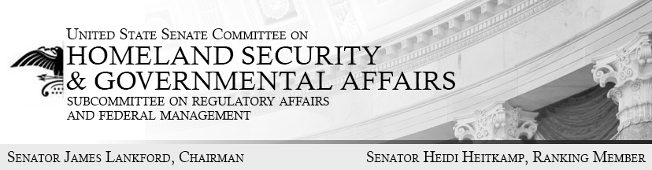
Opening Statement
Hearing before the Regulatory Affairs and
Federal Management Subcommittee,
Wednesday September 13th at 10:00 AM
“Examining OMB’s Memorandum on the Federal Workforce, Part II: Expert Views on OMB’s Ongoing Government-wide Reorganization”
Good morning and welcome to today’s hearing titled “Examining OMB’s Memorandum on the Federal Workforce, Part II: Expert Views on OMB’s Ongoing Government-wide Reorganization.” This is the subcommittee’s second hearing on OMB’s ongoing government-wide reorganization effort.
Three months ago we heard from four executive branch agencies regarding their plans and progress towards achieving the targets and deadlines outlined in OMB’s memorandum titled “Comprehensive Plan for Reforming the Federal Government and Reducing the Federal Civilian Workforce.”
In our first hearing on the reorganization, the Departments of Commerce, Justice, Agriculture, and Homeland Security praised OMB’s leadership and inclusive approach in managing the reorganization process to improve the effectiveness and efficiency of the federal government. These four agencies lauded OMB’s decision to collect input from federal employees, managers, executives—and most importantly—the American public to streamline operations, eliminate duplicative programs, and reduce wasteful spending.
Further, we learned that OMB provided agencies with an aggressive, yet achievable timeline to complete and submit their proposals for consideration. Agencies were to submit three items to OMB by June 30, 2017: draft agency reform plans, plans to maximize employee performance, and progress reports on “near-term workforce reduction actions.” OMB then consulted with these agencies on their proposals, especially regarding cross-cutting issues affecting multiple agencies and programs across the federal government. By the end of this month, agencies are supposed to incorporate OMB’s feedback and submit their refined draft reform plans to OMB.
At this point in the reorganization efforts, this subcommittee has heard positive news from many federal agencies regarding their progress towards achieving the OMB reorganization’s goals. We are also well aware of the costly duplication of programs performed by different agencies across government. For example, the Federal Transit Administration administers $3.6 billion in grants to be awarded toward transit resilience projects. However, GAO reports that it is likely that the Federal Transit Administration grants duplicate funding from other agencies.
But duplication doesn’t just happen across agencies; it exists within agencies as well. For instance, in addition to the Department of Justice Criminal Division, DOJ has four divisions which operate their own, separate criminal sections.
These are not isolated examples. GAO keeps a running list of duplicative federal programs. They have already identified 79 new examples this year, and currently, GAO estimates that 395 such examples have not been fully addressed.
Timely and common sense reorganization is something we need to work towards in order to make government more responsive to the people it serves. Congress needs to be included in this process, especially if OMB plans to propose executive reorganization authority or other legislative changes which would be necessary to improve the effectiveness and efficiency of the federal government.
The reformation of federal bureaucracy should not be a partisan issue. In fact, it is something Presidents from both parties have tried to do for more than 20 years. In his State of the Union address in 1996, President Clinton famously declared that “the era of big government is over. He committed “to give the American people a smaller, less bureaucratic government in Washington and one that lives within its means.” Similarly, President Obama remarked that “we live in a 21st century economy, but we’ve still got a government organized for the 20th century.” He went on to say “our economy has fundamentally changed – as has the world – but the government has not . . . . The needs of our citizens have fundamentally changed but their government has not. Instead, it has often grown more complex.”
Presidents Clinton, Bush, and Obama all sought to reform the federal government to make it leaner and more efficient for the American people. We have a duty to put partisanship aside so that we can accomplish the reform that has been so necessary and yet so elusive for more than 20 years.
The Subcommittee intends to continue to work with this Administration to ensure this reorganization effort is transparent and ultimately successful. We look forward to hearing testimony from OMB on this matter in the near future.
Thankfully, our four expert witnesses today, from a diverse array of outside groups, will provide much-needed insight into OMB’s approach and central role in implementing the reorganization. Today’s witnesses possess prior executive branch experience and management reform expertise, which enables them to offer valuable perspectives on the reorganization. Drawing on lessons from the successes and failures of past attempts to reorganize and streamline the government, we look forward to discussing the issues surrounding government reorganization.
I have the privilege of serving tens of thousands of federal civil servants from Oklahoma and seek to ensure this reorganization improves their effectiveness as they serve the American people. I look forward to hearing from our witnesses today on how we all can work together to deliver a successful reorganization for the American people.
With that, I recognize Ranking Member Heitkamp for her opening remarks.

